So, you want to buy a car…
But you don’t know which one exactly you want, which brand, color, year, sedan or truck? But you only know that you will not drive this car for the rest of your life and you definitely want to sell it later… let’s say when you reach 100,000 miles. I will give you an example how a price of a car changes with increasing mileage. We will take a look at Ford, Chevrolet and Dodge all type of cars built 2010 or later. Data was gathered from online listings.
To show relation between mileage and price of the car and predict the average price of the car with 100 k mileage we will build a statistical model called linear regression.
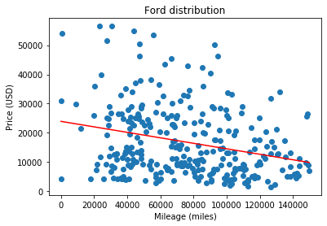
The red regression line doesn’t fit our data well with R squared = 0.07. The closer R squared to 1 the better linear model explains Variation.
But we must remember that we are getting very dispersed data because of our scope. We are looking at all types of cars, all conditions etc. Which means for example that we can see some old cars after restoration which cost much more than same car without upgrades. But we are not looking for exact price of the car with 100k mileage. We want to see which car is better to buy if you have a plan to sell it at 100k miles.
So, let’s use this regression for a prediction and then we will get that average price for a Ford car with 100k miles is $ 14542.
Let’s take a look at other brands with same methodology.
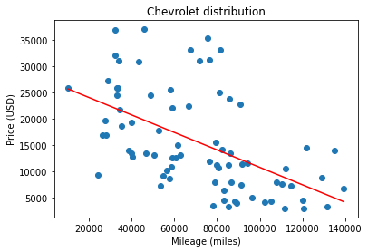
Predicted price for average Chevrolet car with 100k mileage will be $10796. With R squared = 0.28
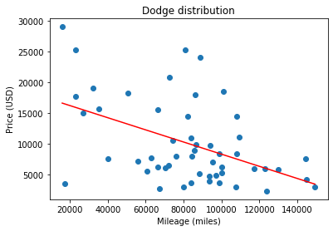
Predicted price for average Dodge car with 100k mileage will be $8294. With R squared = 0.22
Our data is very dispersed but we can try to use polynomial regression to fit the line better.
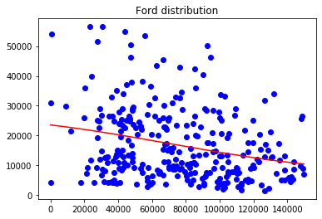
Polynomial regression for Ford is not a lot different from linear one. Predicted price will be $14390 and R squared = 0.07
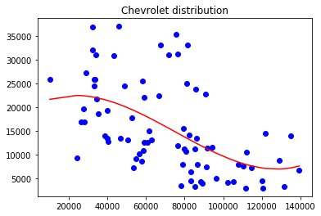
For Chevrolet we see a little difference. Predicted price is $9704 with R squared = 0.29

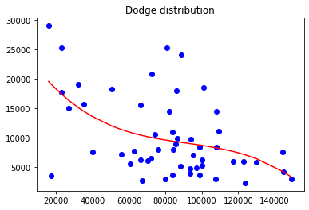
Predicted price for Dodge is $8669 with R squared = 0.24
So, what does it all mean?
We must confirm that our data (it’s scope) is not allowing us to make precise prediction about how much money exactly will you get if you will sell your car at 100k miles. Because we don’t exactly know which car you have. So we took a look at all of them.
But in very general we can say that Ford cars with 100k mileage look on average little more expensive on the market comparing to Chevrolet and Dodge.
So, if you equally like these car brands you should buy Ford and then you most likely will get extra $2000 when you will sell it with 100k mileage.

